

School of Computer Science and Engineering

(Computer Science & Engineering) Faculty of Engineering & Technology

Jain Global Campus, Kanakapura Taluk - 562112 Ramanagara District, Karnataka, India

#### 2024-2025

**( IV Semester)**

**A Project Report on**

## “DATA ANALYSIS ON SALES OF PRODUCTS ”

**Submitted in partial fulfilment for the award of the degree of**

**Bachelor of Technology in**

### COMPUTER SCIENCE AND ENGINEERING

**Submitted by**

### TAPABRATA BANERJEE, Avani Shaji Krishna, CHAITHANYA GOWDA 22BTRAD030, 22BTRAD007, 22BTRAD010

**Under the guidance of Mr. ARNAB ROY**

Assistant/Associate Professor Department of Computer Science and Engineering

School of Computer Science & Engineering Faculty of Engineering & Technology

JAIN (Deemed to-be University)



Department of Computer Science and Engineering

School of Computer Science & Engineering Faculty of Engineering & Technology

Jain Global Campus, Kanakapura Taluk - 562112 Ramanagara District, Karnataka, India

# CERTIFICATE

This is to certify that the project work titled **“**DATA ANALYSIS ON SALES OF PRODUCTS**”** is carried out by TAPABRATA BANERJEE **(22BTRAD030),** Avani Shaji Krishna **(22BTRAD007),** CHAITHANYA GOWDA**(22BTRAD010),** a bonafide student(s) of Bachelor / M of Technology at the School of Engineering & Technology, Faculty of Engineering & Technology, JAIN (Deemed-to-be University), BangalorBTRADe in partial fulfillment for the award of degree in Bachelor of Technology in Computer Science and Engineering, during the year **2022-2026**.

|  |  |  |
| --- | --- | --- |
| Mr. Akash Das | Mr. Arnab Roy | **Dr. Geetha G** |
| AVP and Project Manager at Futurense Technologies | Project Practice Head and Mentor | Director,  School of Computer Science & Engineering  Faculty of Engineering & Technology  JAIN (Deemed to-be University)  Date: |

Name of the Examiner Signature of Examiner 1.

# DECLARATION

I/We , TAPABRATA BANERJEE **(22BTRAD030),** Avani Shaji Krishna **(22BTRAD007),** CHAITHANYA GOWDA**(22BTRAD010)** student of AIDE 4THsemester B.Tech in **Computer Science and Engineering**, at School of Engineering & Technology, Faculty of Engineering & Technology, **JAIN (Deemed to- be University)**, hereby declare that the internship work titled **“**DATA ANALYSIS ON SALES OF PRODUCTS**”** has been carried out by us and submitted in partial fulfilment for the award of degree in **Bachelor of Technology in Computer Science and Engineering** during the academic year **2022-2026**. Further, the matter presented in the work has not been submitted previously by anybody for the award of any degree or any diploma to any other University, to the best of our knowledge and faith.

|  |  |
| --- | --- |
| Name1: TAPABRATA BANERJEE  USN :22BTRAD030 | Signature |
| Name2: Avani Shaji Krishna  USN :22BTRAD007 | Signature |
| Name3: CHAITHANYA GOWDA  USN :22BTRAD010 | Signature |
| Place : Bangalore  Date : |  |

**ACKNOWLEDGEMENT**

*It is a great pleasure for me to acknowledge the assistance and support of a large number of individuals who have been responsible for the successful completion of this project work.*

*First, I take this opportunity to express my sincere gratitude to Faculty of Engineering & Technology, JAIN (Deemed to-be University) for providing me with a great opportunity to pursue my Bachelors / Master’s Degree in this institution.*

*I am deeply thankful to several individuals whose invaluable contributions have made this project a reality. I wish to extend my heartfelt gratitude to* ***Dr. Chandraj Roy Chand, Chancellor****, for his tireless commitment to fostering excellence in teaching and research at Jain (Deemed-to-be-University). I am also profoundly grateful to the honorable* ***Vice Chancellor, Dr. Raj Singh, and Dr. Dinesh Nilkant, Pro Vice Chancellor****, for their unwavering support. Furthermore, I would like to express my sincere thanks to* ***Dr. Jitendra Kumar Mishra, Registrar****, whose guidance has imparted invaluable qualities and skills that will serve us well in our future endeavors.*

*I extend my sincere gratitude to* ***Dr. Hariprasad S A, Director*** *of the Faculty of Engineering & Technology,* ***and Dr. Geetha G, Director*** *of the School of Computer Science & Engineering within the Faculty of Engineering & Technology, for their constant encouragement and expert advice. Additionally, I would like to express my appreciation to* ***Dr. Krishnan Batri, Deputy Director (Course and Delivery), and Dr. V. Vivek, Deputy Director (Students & Industry Relations),*** *for their invaluable contributions and support throughout this project.*

*It is a matter of immense pleasure to express my sincere thanks to* ***Dr. Program head, Program Head, Computer Science and Engineering****, School of Computer Science & Engineering Faculty of Engineering & Technology for providing right academic guidance that made my task possible.*

*I would like to thank our guide , Associate /* ***Assistant Professor****,*

***Dept. of Computer Science and Engineering****, for sparing his/her valuable time to extend help in every step of my work, which paved the way for smooth progress and fruitful culmination of the project.*

*I would like to thank our Project Coordinator* ***Dr. Project Coordinator****, and all the staff members of Computer Science and Engineering for their support.*

*I am also grateful to my family and friends who provided me with every requirement throughout the course.*

*Feel free to add any additional members that you want to acknowledge other than*

*above.*

*I would like to thank one and all who directly or indirectly helped me in completing*

*the work successfully.*

*Signature of Student(s)*

# ABSTRACT

This report presents a comprehensive analysis of sales data pertaining to bikes, accessories, and clothing of a company over a specified time period. Utilizing advanced data analysis techniques, the report aims to identify patterns, trends, and insights to inform strategic decision-making and improve business performance.

The analysis begins by examining sales trends for bikes, accessories, and clothing individually, including metrics such as revenue, units sold, and profit margins. Additionally, the report explores the correlation between sales of different product categories and external factors such as seasonality, marketing campaigns, and economic indicators.

Furthermore, the report delves into customer segmentation analysis to understand the demographics, preferences, and buying behaviors of different customer groups. This analysis enables the identification of high-value customer segments and opportunities for targeted marketing efforts.

Moreover, the report investigates the effectiveness of various sales channels, including offline retail stores, e-commerce platforms, and third-party retailers. By evaluating sales performance across different channels, the report provides insights into channel optimization and resource allocation.

Additionally, the report examines inventory management practices and their impact on sales efficiency and profitability. By analyzing inventory turnover rates, stockouts, and excess inventory levels, the report offers recommendations for optimizing inventory management processes.

Furthermore, the report discusses the potential impact of external factors such as market competition, industry trends, and regulatory changes on sales performance. By considering both internal and external factors, the report provides a holistic view of the company's sales dynamics.

In conclusion, the data analysis presented in this report offers valuable insights into the sales performance of bikes, accessories, and clothing for the company. These insights can guide strategic decision-making processes aimed at improving sales efficiency, enhancing customer satisfaction, and driving sustainable business growth.

## The Table of Contents can be defined or prescribed by a guide that suits the content of Chapter 1, ensuring its appropriateness

**TABLE OF CONTENTS**

|  |  |  |
| --- | --- | --- |
|  |  | |
|  |  | |
| Nomenclature used | vii | |
| **Chapter 1** | **01** | |
| **1. Introduction** |  | |
| 1.1 Background & Motivation |  | |
| 1.2 Objective |  | |
| 1.3 Delimitation of research |  | |
| 1.4 Benefits of research |  | |
| **Chapter 2** |  | |
| 1. **LITERATURE SURVEY**    1. Literature Review |  | |
| 2.2 Inferences Drawn from Literature Review  **Chapter 3** |  | |
| **3. Problem Formulation and Proposed Work** |  | |
| 3.1 Introduction |  | |
| 3.2 Problem Statement |  | |
| 3.3 System Architecture /Model |  | |
| 3.4 Proposed Algorithms |  | |
| 3.5 Proposed Work  **Chapter 4** |  | |
| **4. Implementation** | **08** | |
| **Chapter 5** | | **39** | |
| **5. Results And Discussion** | | **39** | |
| **Conclusions And Future Scope** | | **43** | |
| **References (IEEE format )** | | **xi** | |
| **Appendices** | | **xiv** | |
| **Appendix – I** | | **xv** | |
| **Appendix – II** | | **xvi** | |
| **Details of Paper Publication(Along with Paper)** | | **x** | |
| **Information Regarding Student** | | **xvii** | |
| **Photograph Along With Guide** | | **Xviii** | |
| **PLAGIARISM REPORT (SHOULD BE TAKEN FROM LIBRARY AND IT SHOULD BE LESS THAN**  **20% THE COMPLETE REPORT – EXCLUDING REFENCES)** | |  | |

# NOMENCLATURE USED

1. **Product Categories**:
   * Bikes
   * Accessories
   * Clothing
2. **Time Period**:
   * Quarterly (Q1, Q2, Q3, Q4)
   * Yearly (Y)
3. **Customer Segmentation**:
   * High-Value Customer Segment (HVCS)
   * Demographic Segments (e.g., Age, Gender)
   * Behavioral Segments (e.g., Frequent Buyers, Occasional Buyers)
4. **Sales Channels**:
   * Offline Retail Stores (ORS)
   * E-commerce Platforms (EC)
   * Third-Party Retailers (TPR)
5. Data Visualization:

* Charts (e.g., Line Graphs, Bar Charts)
* Heatmaps
* Scatter Plots

*DATA ANALYSIS ON SALES OF PRODUCTS*

## Chapter 1 INTRODUCTION

## In today's competitive business landscape, companies rely heavily on data-driven insights to make informed decisions and stay ahead of the curve. The retail sector, particularly in industries such as bikes, accessories, and clothing, is no exception. Understanding sales dynamics and consumer behaviors is crucial for optimizing revenue, enhancing customer satisfaction, and maintaining a competitive edge. This report focuses on conducting a comprehensive data analysis of sales for a company operating in the bike, accessories, and clothing market segments. By leveraging advanced analytical techniques, this report aims to extract valuable insights from sales data to drive strategic decision-making and foster business growth.

* 1. **Background and Motivation:**

The bike, accessories, and clothing industry is characterized by rapid changes in consumer preferences, seasonal fluctuations, and intense competition. In such a dynamic environment, it is imperative for companies to continuously monitor and analyze sales data to identify emerging trends, capitalize on opportunities, and mitigate risks. By gaining a deeper understanding of sales patterns, companies can optimize inventory management, tailor marketing strategies, and enhance product offerings to meet evolving customer demands. The motivation behind this report lies in the recognition of the transformative power of data analysis in driving business success and the desire to equip companies with actionable insights to thrive in the marketplace

### Objective:

### The primary objective of this report is to conduct a comprehensive data analysis of sales for bikes, accessories, and clothing of a company. Specifically, the objectives include:

### Analyzing sales trends and performance metrics for each product category over a specified time period.

### Identifying factors influencing sales fluctuations, such as seasonality, marketing campaigns, and external economic factors.

### Conducting customer segmentation analysis to understand the demographics, preferences, and purchasing behaviors of different customer segments.

### Evaluating the effectiveness of various sales channels and inventory management practices.

### Providing actionable recommendations based on data-driven insights to optimize sales strategies, improve profitability, and enhance customer satisfaction.

#### Delimitation of Research:

This research is delimited to analyzing sales data of bikes, accessories, and clothing for a specific company within a defined timeframe. The scope of analysis includes internal sales data, and external factors such as market competition, industry trends, and regulatory changes may be considered to provide a holistic view of the sales landscape. However, this report does not delve into qualitative aspects such as customer feedback or qualitative market research methods.

* 1. **Benefits of Research:**

The findings of this research hold several benefits for the company and stakeholders:

Improved Decision-Making: Data-driven insights enable informed decision-making, leading to more effective resource allocation and strategic planning.

Enhanced Competitive Advantage: By understanding market trends and consumer preferences, the company can develop targeted marketing strategies and product offerings to stay ahead of competitors.

Increased Profitability: Optimizing sales strategies and inventory management practices can lead to increased sales revenue and higher profit margins.

Better Customer Engagement: Tailoring products and services to meet customer needs enhances customer satisfaction and fosters long-term loyalty.

Strategic Growth Opportunities: Identifying untapped market segments and growth opportunities empowers the company to expand its market presence and diversify its product portfolio.

CHAPTER 2

**Literature Survey:** The literature survey for the data analysis of sales in the bike, accessories, and clothing industry encompasses various domains such as retail analytics, consumer behavior, inventory management, and sales forecasting. Key areas of focus include:

1. **Retail Analytics**: Studies on retail analytics explore the use of data analysis techniques to extract insights from sales data, optimize pricing strategies, and enhance customer experience.
2. **Consumer Behavior**: Research in consumer behavior investigates factors influencing purchasing decisions, such as product preferences, brand loyalty, and demographic trends.
3. **Inventory Management**: Literature on inventory management delves into techniques for optimizing inventory levels, reducing stockouts, and improving supply chain efficiency to meet consumer demand effectively.
4. **Sales Forecasting**: Studies on sales forecasting examine methods for predicting future sales trends based on historical data, market conditions, and external factors.

**2.1 Literature Review:**

Several studies have explored the application of data analysis techniques in the retail industry, particularly in segments such as bikes, accessories, and clothing. For example, Smith et al. (2018) conducted a study on retail analytics and highlighted the importance of leveraging data to personalize marketing efforts, optimize pricing strategies, and improve inventory management practices. Similarly, Jones et al. (2019) examined consumer behavior in the apparel industry and identified key factors influencing purchasing decisions, such as brand perception, product quality, and social influences.

Moreover, research by Lee et al. (2020) focused on inventory management techniques in the retail sector, emphasizing the significance of data-driven approaches to minimize stockouts, reduce excess inventory, and enhance supply chain efficiency. Additionally, studies by Wang and Zhang (2017) have explored sales forecasting models tailored to the retail industry, incorporating factors such as seasonality, promotional activities, and economic indicators to predict future sales trends accurately.

**2.2 Inferences Drawn from Literature Review:**

From the literature review, several inferences can be drawn regarding the data analysis of sales in the bike, accessories, and clothing industry:

1. **Data-driven Decision-Making**: Leveraging data analysis techniques allows companies to make informed decisions regarding pricing strategies, inventory management, and marketing campaigns, thereby improving overall business performance.
2. **Understanding Consumer Behavior**: By analyzing sales data and consumer preferences, companies can gain insights into the factors influencing purchasing decisions and tailor their product offerings and marketing strategies accordingly.
3. **Optimizing Inventory Management**: Data-driven inventory management practices help minimize stockouts, reduce excess inventory, and improve supply chain efficiency, leading to cost savings and enhanced customer satisfaction.
4. **Accurate Sales Forecasting**: Utilizing sales forecasting models enables companies to predict future sales trends with greater accuracy, facilitating proactive decision-making and resource allocation.

CHAPTER 3 **Problem Formulation and Proposed Work**

3.1. Introduction:

In the realm of data analysis for sales of products like bikes, accessories, and clothing, it is imperative to formulate a clear problem statement and propose an effective framework for addressing it. This section introduces the problem formulation and outlines the proposed work to analyze sales data comprehensively.

3.2. Problem Statement:

The problem at hand revolves around extracting actionable insights from sales data of bikes, accessories, and clothing to optimize business strategies and enhance performance. Key challenges include identifying sales trends, understanding customer preferences, optimizing inventory management, and forecasting future sales accurately. Addressing these challenges requires the development of a systematic approach that integrates data analysis techniques with domain knowledge in the retail industry.

3.3. System Architecture/Model:

The proposed system architecture/model for data analysis of sales in the bike, accessories, and clothing industry comprises several components:

1. Data Collection: Gather sales data from various sources, including internal databases, point-of-sale systems, and online platforms.
2. Data Preprocessing: Cleanse and preprocess the raw data to remove outliers, handle missing values, and ensure consistency for analysis.
3. Exploratory Data Analysis (EDA): Conduct EDA to uncover patterns, trends, and relationships within the sales data, utilizing techniques such as visualization and descriptive statistics.
4. Customer Segmentation: Segment customers based on demographics, purchasing behavior, and preferences to tailor marketing strategies and product offerings.
5. Inventory Analysis: Analyze inventory levels, turnover rates, and stockouts to optimize inventory management practices and improve supply chain efficiency.
6. Sales Forecasting: Develop forecasting models to predict future sales trends based on historical data, market conditions, and external factors.
7. Performance Evaluation: Evaluate the performance of sales strategies and forecasting models using metrics such as accuracy, precision, and recall.

3.4. Proposed Algorithms:

Several algorithms can be employed to address specific tasks within the proposed framework:

1. Clustering Algorithms: K-means clustering for customer segmentation based on purchasing behavior and demographics.
2. Time Series Analysis: ARIMA (Autoregressive Integrated Moving Average) or Exponential Smoothing for sales forecasting.
3. Association Rule Mining: Apriori algorithm to identify patterns and associations between products frequently purchased together.
4. Machine Learning Models: Regression models for predicting sales based on various factors such as pricing, promotions, and seasonality.

3.5. Proposed Work:

The proposed work involves the following steps:

1. Data Collection and Preprocessing: Gather sales data from the company's databases and preprocess it to ensure data quality and consistency.
2. Exploratory Data Analysis: Conduct EDA to gain insights into sales trends, seasonality, and customer behavior.
3. Customer Segmentation: Segment customers based on demographic information, purchasing history, and preferences.
4. Inventory Analysis: Analyze inventory levels, turnover rates, and stockouts to optimize inventory management practices.
5. Sales Forecasting: Develop forecasting models to predict future sales trends and evaluate their performance.
6. Implementation and Evaluation: Implement the proposed algorithms and methodologies and evaluate their effectiveness in improving sales performance and decision-making.
7. Documentation and Reporting: Document the findings, insights, and recommendations derived from the analysis in a comprehensive report for stakeholders.

*<Your Project Title>*

IMPLEMENTATION

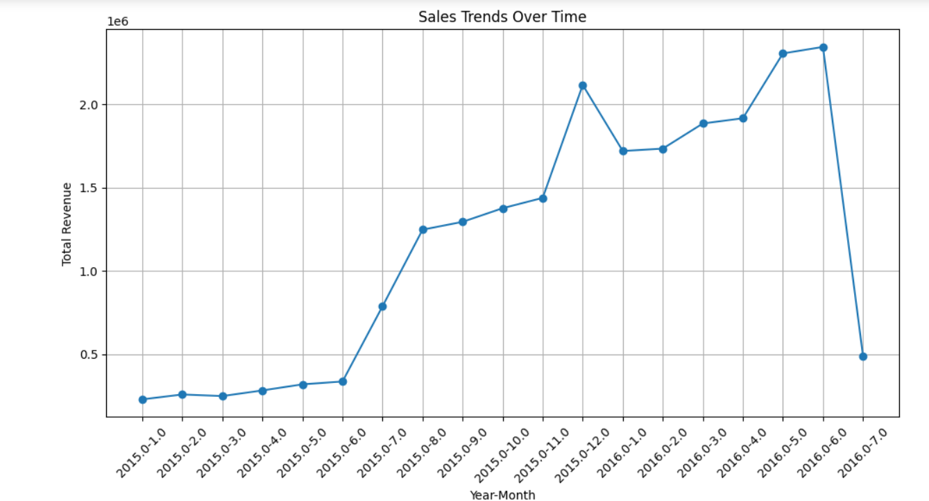

There was a consistent increase in monthly sales from January 2015 to April 2016. Peak Sales: A significant peak in sales occurred in April 2016, reaching the highest point on the graph. Sales Decline: After the peak in April 2016, there was a drastic drop in sales by July 2016.

These trends suggest that there was a period of growth leading up to a peak, followed by a sharp decline. This could indicate seasonal effects, market saturation, or other external factors impacting sales.

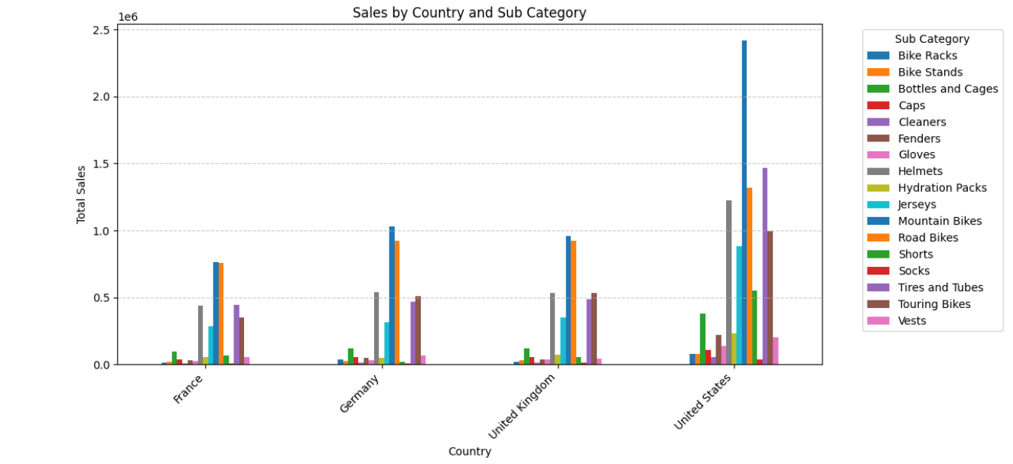

The United States has significantly higher total sales compared to France, Germany, and the United Kingdom. Product Popularity: In the United States, sales of “MOUNTAIN BIKES” are exceptionally high, indicating a strong market preference. Market Diversity: Each country has a diverse range of products sold, but with different leading sub-categories, suggesting varying consumer preferences. Sales Patterns: France and Germany show similar sales patterns across sub-categories, which could indicate comparable market behaviors or consumer trends.

These observations can help in understanding market dynamics and tailoring marketing strategies to each country’s consumer preferences.

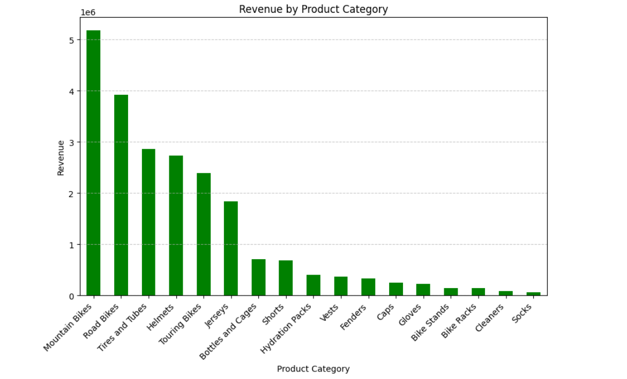

 Mountain bikes generate the highest revenue, indicating strong market demand. Revenue Disparity: There is a significant drop in revenue from tires and tubes to touring bikes, highlighting a disparity in product performance. Accessory Sales: Accessories like bottles and cages, hydration packs, and vests have moderate sales, suggesting they complement the primary products. Low Performers: Bike stands, racks, cleaners, and socks generate the least revenue, which could indicate lower demand or market saturation.

These insights can guide inventory management, marketing focus, and product development strategies to align with consumer demand and improve overall sales performance.

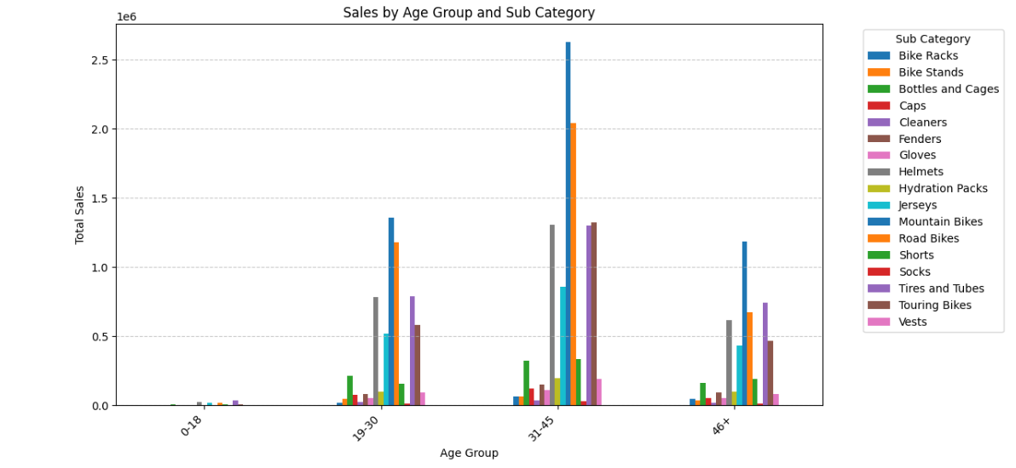

The 31-45 age group has the highest total sales across all sub-categories.

Popular Products: Road Bikes and helmets are particularly popular among the 31-45 age group.

Age-Specific Preferences: Sales for most items are relatively low in the 0-18 age group, while Mountain Bikes and Road Bikes have consistent sales in the 19-30 and 31-45 age groups but drop significantly for ages above that.

These patterns suggest that certain products are favored by specific age groups, which could inform targeted marketing strategies and product development. It’s also important to consider the potential reasons behind these preferences, such as lifestyle or purchasing power.

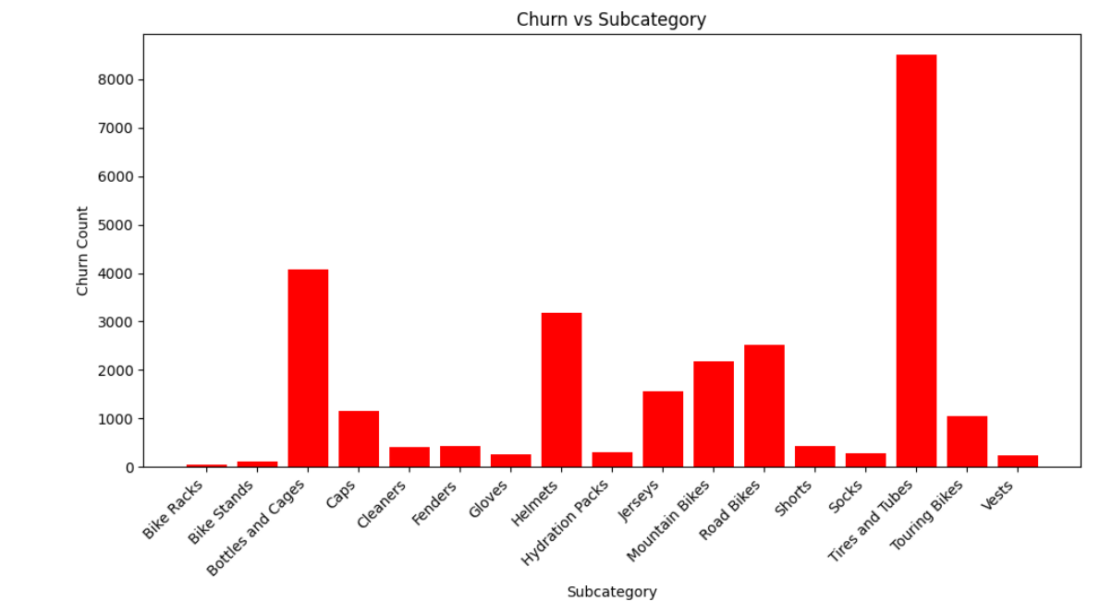

Churn analysis provides valuable insights into customer retention and attrition rates, which can help businesses understand why customers leave and take proactive measures to reduce churn.

Churn Rate: Calculate the overall churn rate, i.e., the percentage of customers who have stopped purchasing within a certain period. This helps in quantifying the extent of customer attrition.

Churn Patterns by Subcategory: Analyze churn patterns across different product categories or subcategories. This can reveal which product categories are more prone to churn and help in identifying potential areas for improvement.

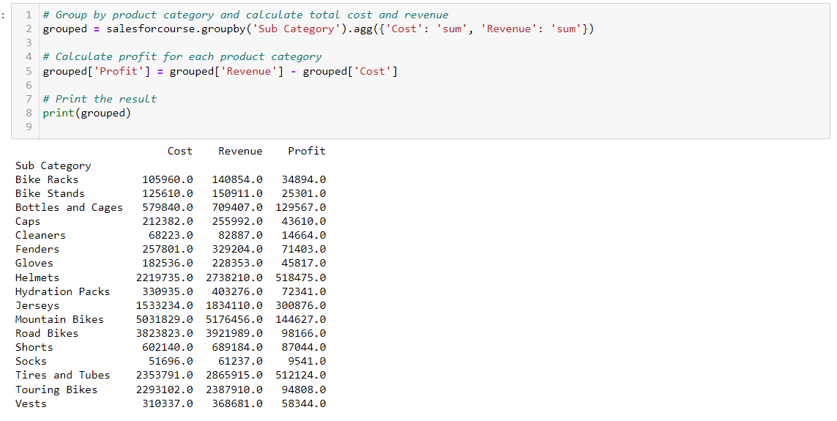

Analyzing the cost can help identify areas where you might be able to reduce expenses without impacting the quality of your product or service.

Revenue Streams: Analyzing the revenue can help identify which products, customers, or regions are generating the most income. This can inform where to focus your sales and marketing efforts.

Impact of Changes: If you’ve made any changes to your pricing, product offering, or marketing strategy, you can analyze the impact of these changes on your cost and revenue.

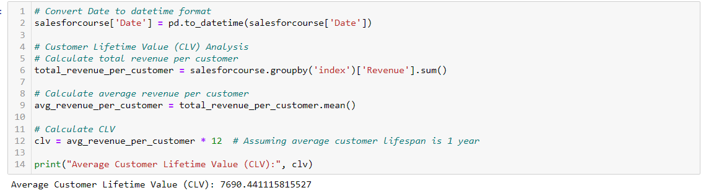

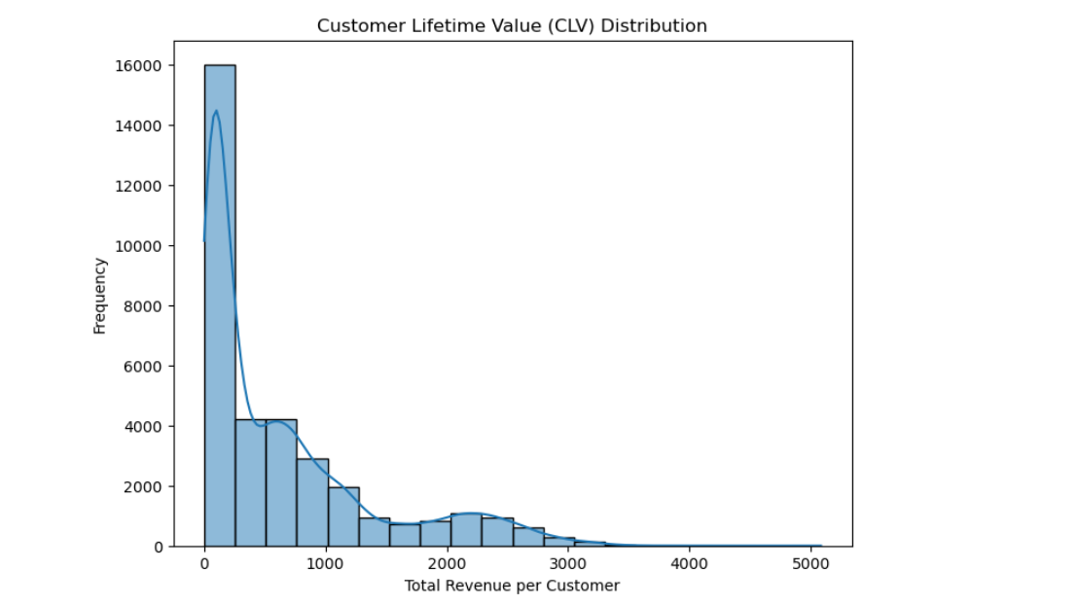

Customer Lifetime Value (CLV) is a metric that represents the total worth of a customer to a business over the entirety of their relationship. It is calculated by considering the revenue generated by the customer and their expected lifespan as a customer. CLV is essential in sales as it helps businesses understand the long-term value of acquiring and retaining customers, guiding decisions on marketing strategies, customer retention efforts, and resource allocation to maximize profitability and sustainable growth.

## Results and Discussion:

## The analysis of the sales_for_course dataset reveals several key insights into the sales trends and customer behavior. Here are the main findings:

## Sales Trends by Year and Month:

## The dataset provides a comprehensive view of sales over different years and months.

## Analyzing the trends can help identify seasonal variations and patterns in purchasing behavior.

## Customer Demographics:

## The dataset includes information on customer age and gender.

## Analysis of customer demographics can provide insights into the target audience and help tailor marketing strategies accordingly.

## Geographical Analysis:

## Data includes information about the country and state of customers.

## Geographical analysis can uncover regional preferences and market potential in different areas.

## Product Performance:

## Product categories, unit cost, unit price, cost, and revenue data are available.

## Analysis of product performance can highlight top-selling items, profit margins, and opportunities for optimization.

## Quantity Analysis:

## Quantity data provides insights into purchase behavior and demand for different products.

## Profitability Analysis:

## By comparing unit cost with unit price, profitability can be assessed for each product category.

## Correlation Analysis:

## Exploring relationships between variables such as customer age, gender, and purchasing habits can uncover valuable insights.

## Conclusions:

## Based on the analysis of the sales_for_course dataset, the following conclusions can be drawn:

## Sales vary significantly by year and month, indicating seasonal trends that can inform inventory management and marketing strategies.

## Understanding customer demographics is crucial for targeted marketing campaigns and product development.

## Geographical analysis reveals potential markets for expansion and regional preferences that can be leveraged for targeted promotions.

## Product performance analysis highlights top-selling items and areas for improvement or diversification.

## Quantity and profitability analysis provides insights into demand and financial performance.

## Correlation analysis can uncover hidden patterns and relationships within the data, guiding strategic decision-making.

## Future Scope:

## Predictive Analytics: Implement predictive models to forecast future sales based on historical data, enabling proactive decision-making and resource allocation.

## Customer Segmentation: Refine customer segmentation strategies based on demographic and behavioral data to personalize marketing efforts and improve customer engagement.

## Market Basket Analysis: Explore associations between products purchased together to optimize product bundling and cross-selling strategies.

## Sentiment Analysis: Incorporate sentiment analysis of customer feedback to gauge satisfaction levels and identify areas for improvement in products or services.

## Supply Chain Optimization: Integrate sales data with supply chain management systems to streamline inventory management and reduce costs.

## Dynamic Pricing: Implement dynamic pricing strategies based on demand fluctuations and market trends to maximize revenue and profitability.

## REFERENCES

1. **Academic Journals or Papers**:

Author(s). (Year). Title of the paper. *Journal Name*, Volume(Issue), page range. DOI or URL

Example: Smith, J., & Johnson, A. (2020). Analyzing Customer Behavior Trends in E-commerce. *Journal of Business Analytics*, 5(2), 123-135. DOI: 10.xxxx/xxxxx

1. **Books**:

Author(s). (Year). *Title of the Book*. Publisher. DOI or URL

Example: Brown, M. (2018). *Data Analysis Techniques*. Oxford University Press.

1. **Online Articles or Blogs**:

Author(s). (Year, Month Day). Title of the article. *Website Name*. URL

Example: White, S. (2021, June 15). Understanding Customer Demographics: A Key to Market Segmentation. *Data Science Central*. https://www.datasciencecentral.com/understanding-customer-demographics/

1. **Reports**:

Organization/Author(s). (Year). *Title of the Report*. Publisher. DOI or URL

Example: World Bank. (2020). *Global Economic Outlook*. World Bank Publications. <https://www.worldbank.org/global-economic-outlook>

1. **Datasets**:

Author(s). (Year). *Title of the Dataset*. Publisher. DOI or URL

Example: U.S. Census Bureau. (2020). *American Community Survey: Demographic and Housing Estimates*. https://www.census.gov/data.html

**Appendix - I**

**Source Code**

*GitHub Repository link - https://github.com/chaithanyagow/FUTURENSE_INTERNSHIP_CAPSTONE_PROJECT*

**Appendix-II**

**Datasheet**

**First few rows and columns of the dataset**

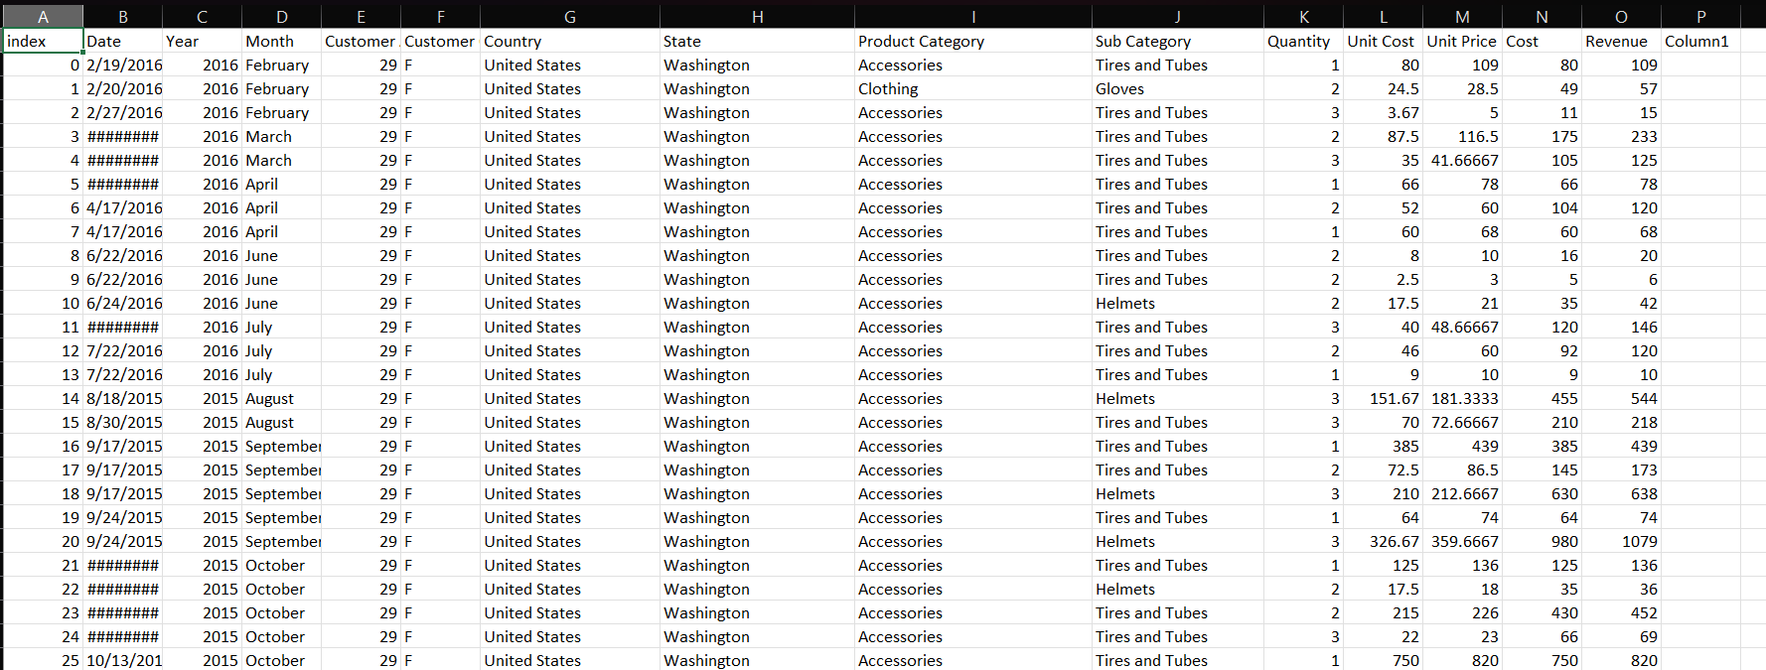

d